Environment configuration

What Is Environment configuration?
# Source: AI Source: Provided by: [Data Path: Persons Table -> ID Column: 1, Name_En Column: Motasem Essam] -> From: [Chatgpt (GPT‑5 Mini)] on [1/26/2026]
Environment configuration is the setup of all the settings, variables, and resources that an application or system needs to run correctly in a specific context.
Think of it as answering: “Where is this app running, and what does it need to know to work here?”

In plain terms
# Source: AI Source: Provided by: [Data Path: Persons Table -> ID Column: 1, Name_En Column: Motasem Essam] -> From: [Chatgpt (GPT‑5 Mini)] on [1/26/2026]
It includes things like:
- Environment variables (e.g., DATABASE_URL, API_KEY)
- System settings (OS, time zone, locale)
- Service connections (databases, caches, message queues)
- Feature flags or mode switches (development vs production)
- Secrets & credentials (usually stored securely, not in code)

Common environments
# Source: AI Source: Provided by: [Data Path: Persons Table -> ID Column: 1, Name_En Column: Motasem Essam] -> From: [Chatgpt (GPT‑5 Mini)] on [1/26/2026]
Most software has multiple environments, each with its own configuration:
- Development – local machine, debug mode on
- Testing / Staging – mirrors production but safer
- Production – live users, performance and security focused
Same code, different configuration.

Simple example
# Source: AI Source: Provided by: [Data Path: Persons Table -> ID Column: 1, Name_En Column: Motasem Essam] -> From: [Chatgpt (GPT‑5 Mini)] on [1/26/2026]
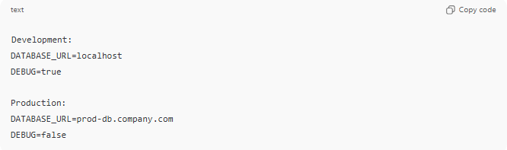
Development:
DATABASE_URL=localhost
DEBUG=true

Production:
DATABASE_URL=prod-db.company.com
DEBUG=false
The code doesn’t change—only the environment configuration does.

Why it matters
# Source: AI Source: Provided by: [Data Path: Persons Table -> ID Column: 1, Name_En Column: Motasem Essam] -> From: [Chatgpt (GPT‑5 Mini)] on [1/26/2026]
- 🔐 Security – secrets aren’t hard-coded
- 🔄 Flexibility – deploy the same app anywhere
- 🧪 Safety – test without breaking production
- 🚀 Scalability – easy to add new environments
Where you’ll see it
- .env files
- Docker & Kubernetes configs
- CI/CD pipelines
- Cloud platforms (AWS, Azure, GCP settings)

